We built a passive house.
A passive house takes maximum advantage of any heat sources (e.g. heat from the sun or the building itself, appliances and people) around or inside the house.
The main goal of building such a house is to prevent a high heating bill in the future.
One of the materials used in building the house is thatch (made from water reed). The framework of the house is made out of wood and there are thatch mats used for insulation.
The wooden walls are very soundproof due to having pores and the layered structure of the material.
For the siding we used lime plaster. You can also use clay plaster due to its ability to breathe and regulate humidity. The building consists of natural materials and is energy efficient.
For the inside of the house casein paint and wood are used.

The following concepts should be followed when building the house:
1. The windows should be facing South to enable using the heat from the Sun. The windows are very important to the house because in addition to keeping the warmth in they also allow the sun to heat the building during sunny weather. The windows also make the house cosy during colder periods since they stop the cold from entering the house.
2. The roof of the house is flat and made out of transparent glass to ensure maximum use of solar energy.
3. There are no obstacles on the South side of the building that would obstruct the sunlight.
4. The house windows are multi-layered ensuring heat saving.
5. The house is compact, has at least two floors and simple architecture (lacking decorative elements such as towers).
6. The appliances and lighting solutions are as energy efficient as possible.
7. Wooden furniture is used.
8. Another heating source used is a slate fireplace.
A thatch house is excellent at preserving heat.
Using solar power (solar panels) you can supplement heating the building and heat water for everyday use. Using modern systems you can heat almost 70% of the water needed and supply almost 50% of the energy needed to heat the building.
If there is a moment during summer where the inner temperature of the house is too high the windows can be opened letting the cooler air to move through the house.
A ventilation system that enables the heat to stay in the building is one of the most important components of a passive house. A heat exchange ventilation system (returns 75%-92% of the heat) enables using a significant part of the heat from the air being led outside to heat up the fresh air coming into the house. Since the loss of heat has been minimized the passive house no longer needs an active heating system. The small amout of warmth lost due to ventilation is compensated by using the heat generated by appliances, people, pets and lighting. Using an ordinary ventilation system a huge part of the heat is transferred outside which makes it impossible to keep the house warm without an active heating source. Forced ventilation ensures proper air circulation and CO content in all parts of the building. The main goal of forced ventilation is to ensure excellent air quality within the house.
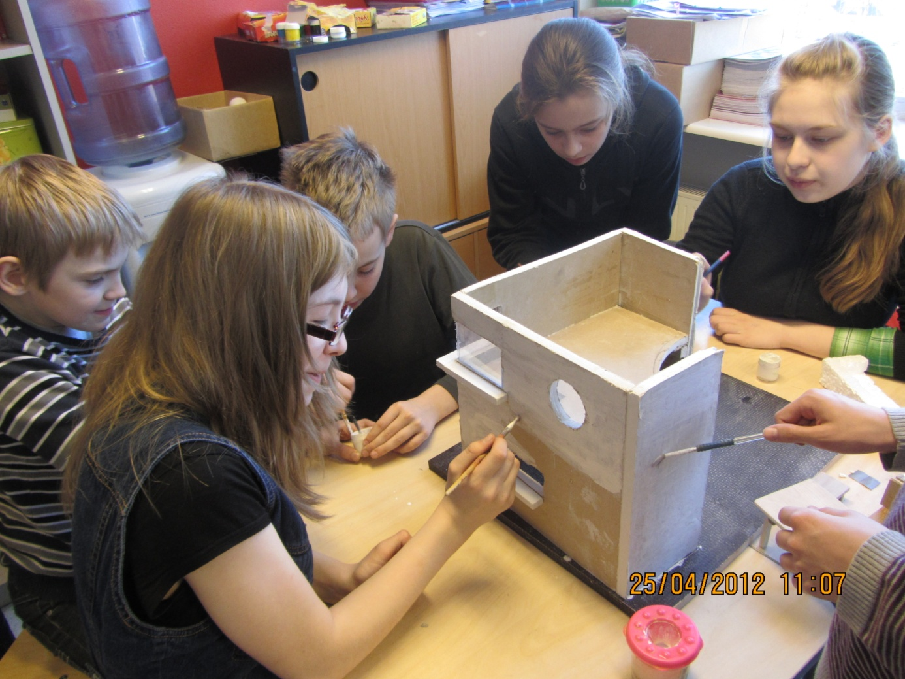

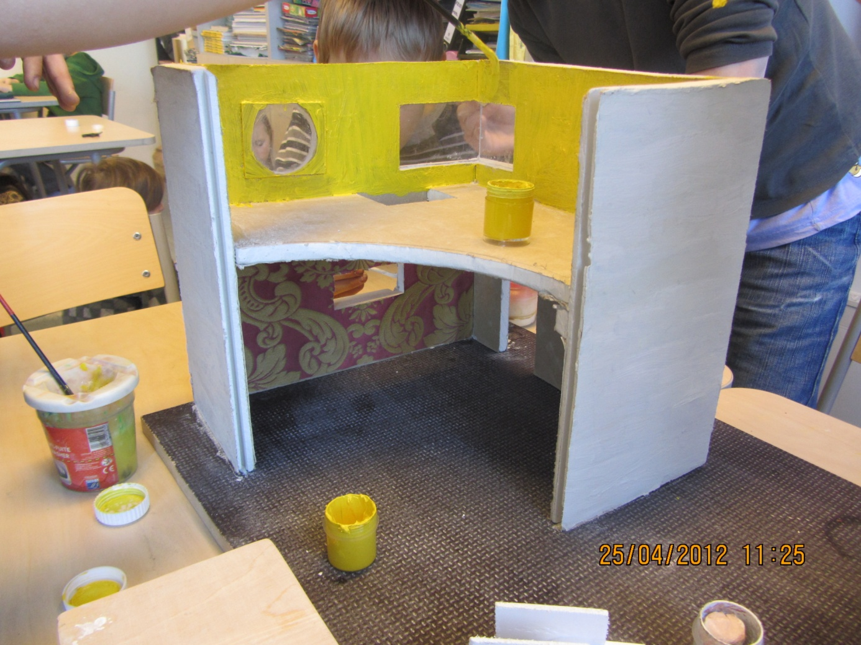

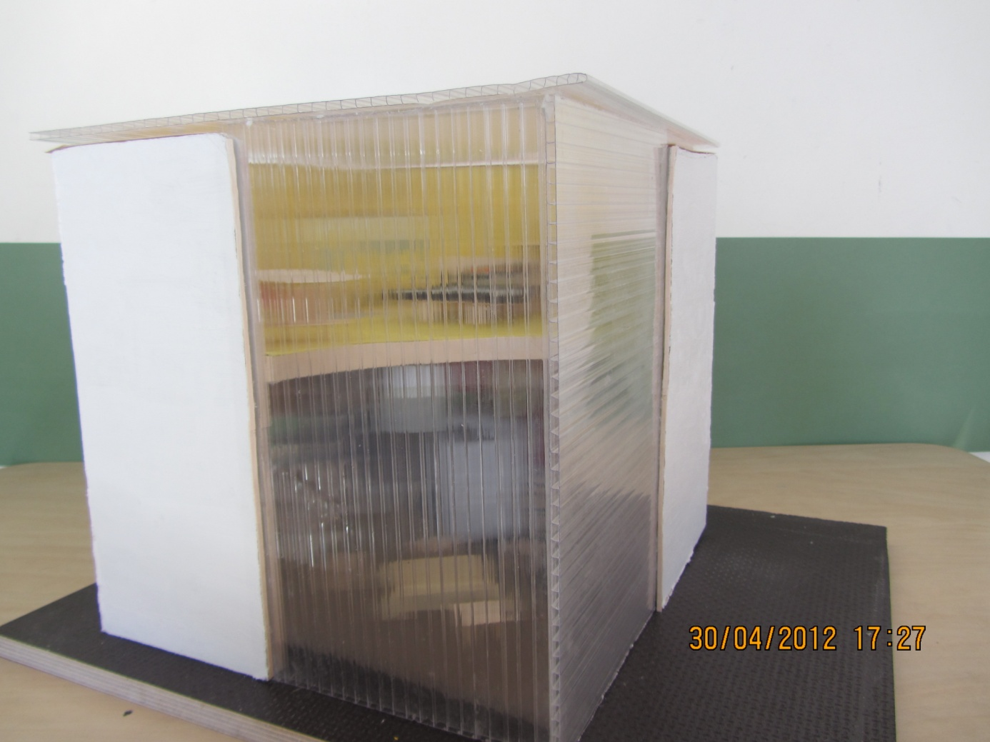

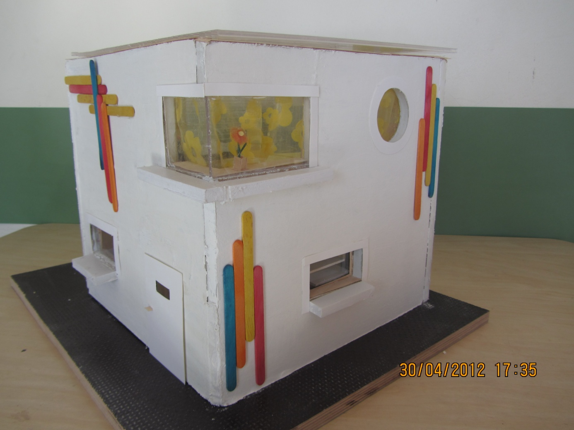

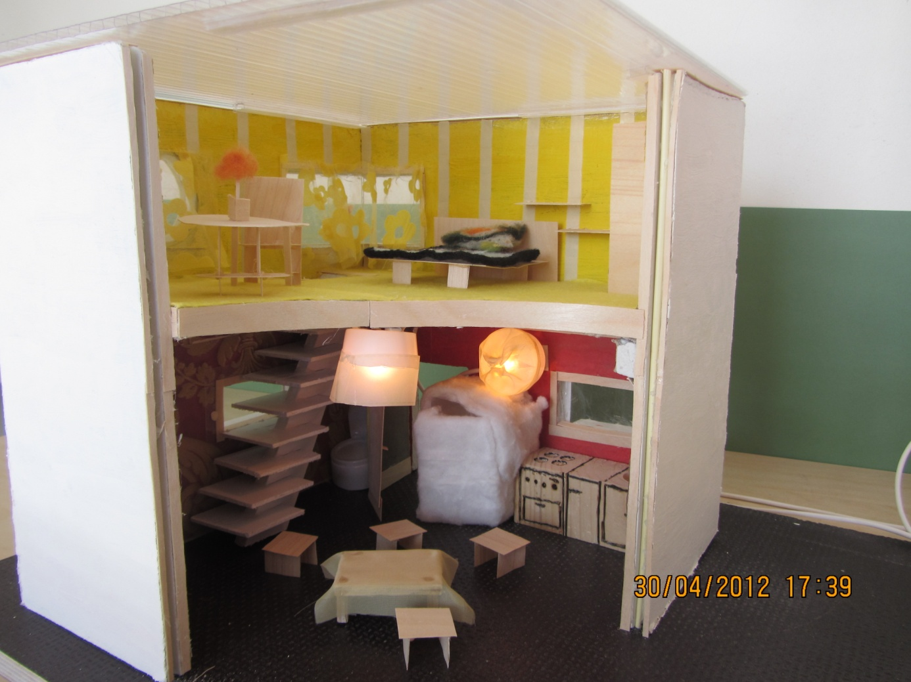

Wall of the house - wood and reed.

