From the past the shape, in an eco friendly present, towards a sustainable future.
We looked back in our ancient origins and history in the Romans time to take suggestions for our green house. The roman domus has been our model and the idea of a house that has to be resistant, usable and art- like and homely as the ancient roman architect Vitruvio maintained.
As in the roman house, the ‘atrium’, an open air room in the center, is a source of light and the hub of the house. All around it there are the different rooms. We planned the house considering to protect the inside room from the hot temperature rather than from the cold one, as we are in a warm Mediterranean area. For both the situation and keeping in our mind the need of sparing energy, we mean to create a thermal insulation by building the walls with different coatings and in the middle a very insulating one made of natural wooden fiber. That is the way for keeping the inside warm in winter, protect from the summer heat and reduce and absorb humidity. The outer walls at north and west will be covered with brick of local stone (tuff, a volcanic local rock) and it has got few small windows to keep the most inside temperature and the other two at south and east will be plastered with natural lime and there’s a porch that protect from the direct hot sun in summer.
Our house is covered partly with clay roof tile and solar panels and partly with a green roof that is a very insulating green area and a garden in the house. We are meaning to have an energy selfish house and collect rain water in a cistern and use it for the hot water heater and to water the garden and to use it in the toilet.
The pipeline from the hot water heater goes under the floor to distribute a warm temperature everywhere or a fresh one depending from the season.
Our plastic house is a square shape of 60 centimetres side. It is made of polystyrene, cardboard and wood.

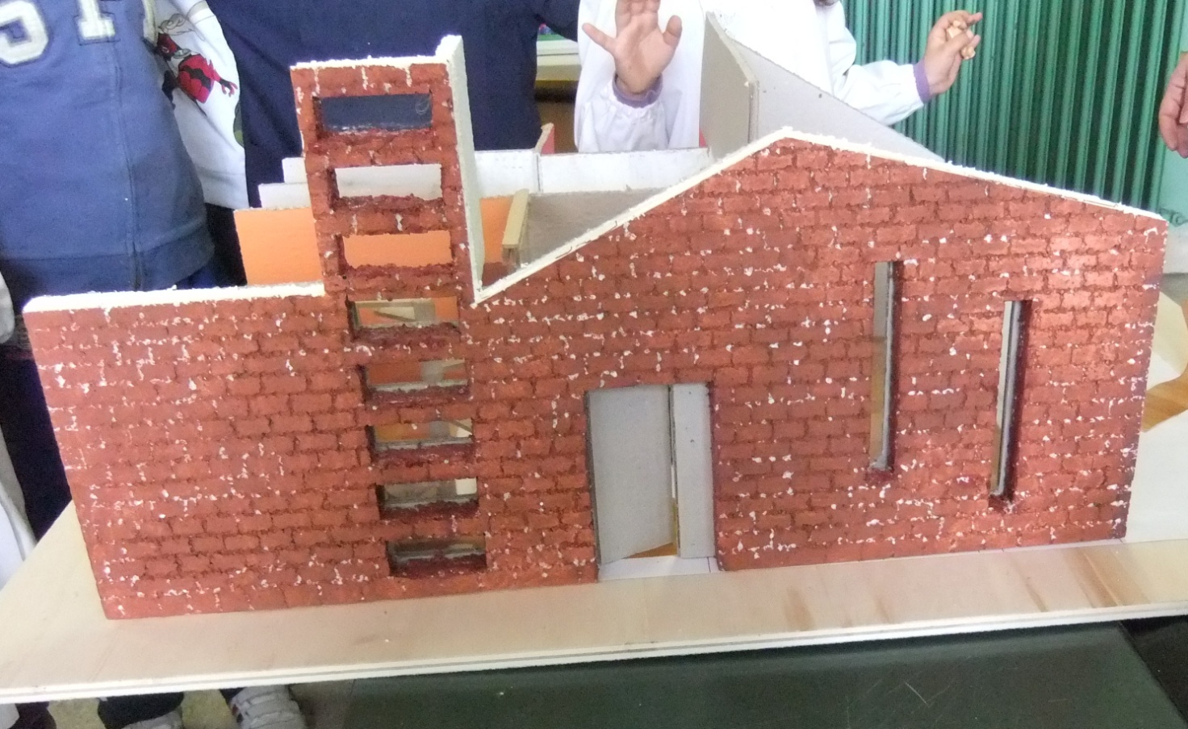
This is the front of the house that is in the south. It is covered with bricks of tuff that is polystyrene and cardboard in the plastic model. There is the front door in the middle that we have to paint yet in this photo, two long windows to give light to the dining and living room inside. The eight windows on the left is the front of the little tower where there is the winding staircase inside.
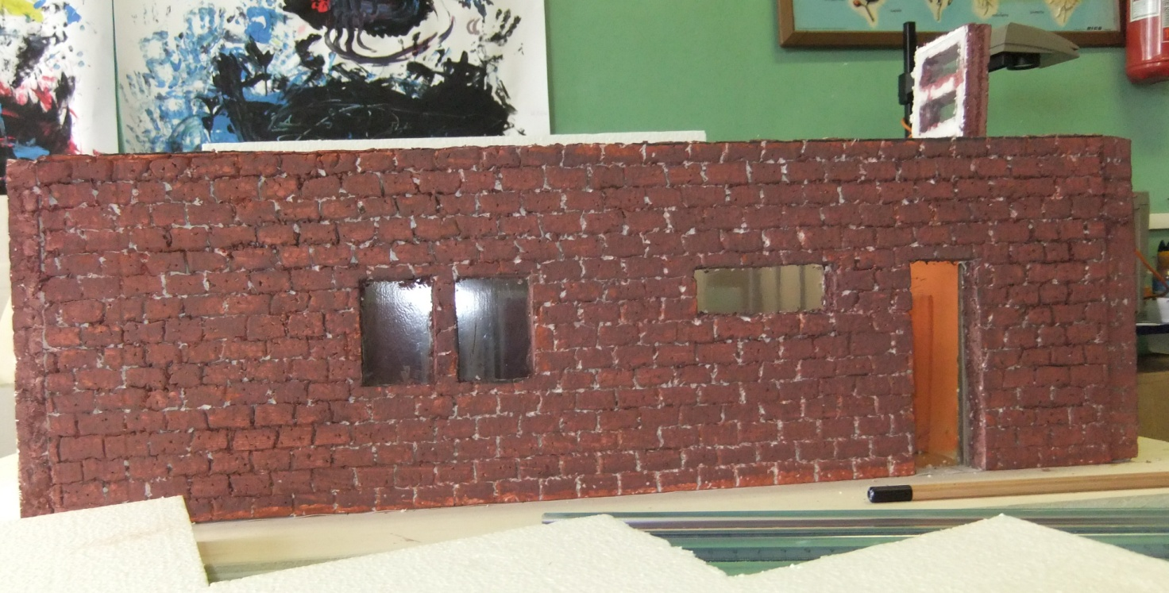
This is the west side of the house with the two windows of the two bathrooms on the left and the wide and the long windows of the kitchen on the right.
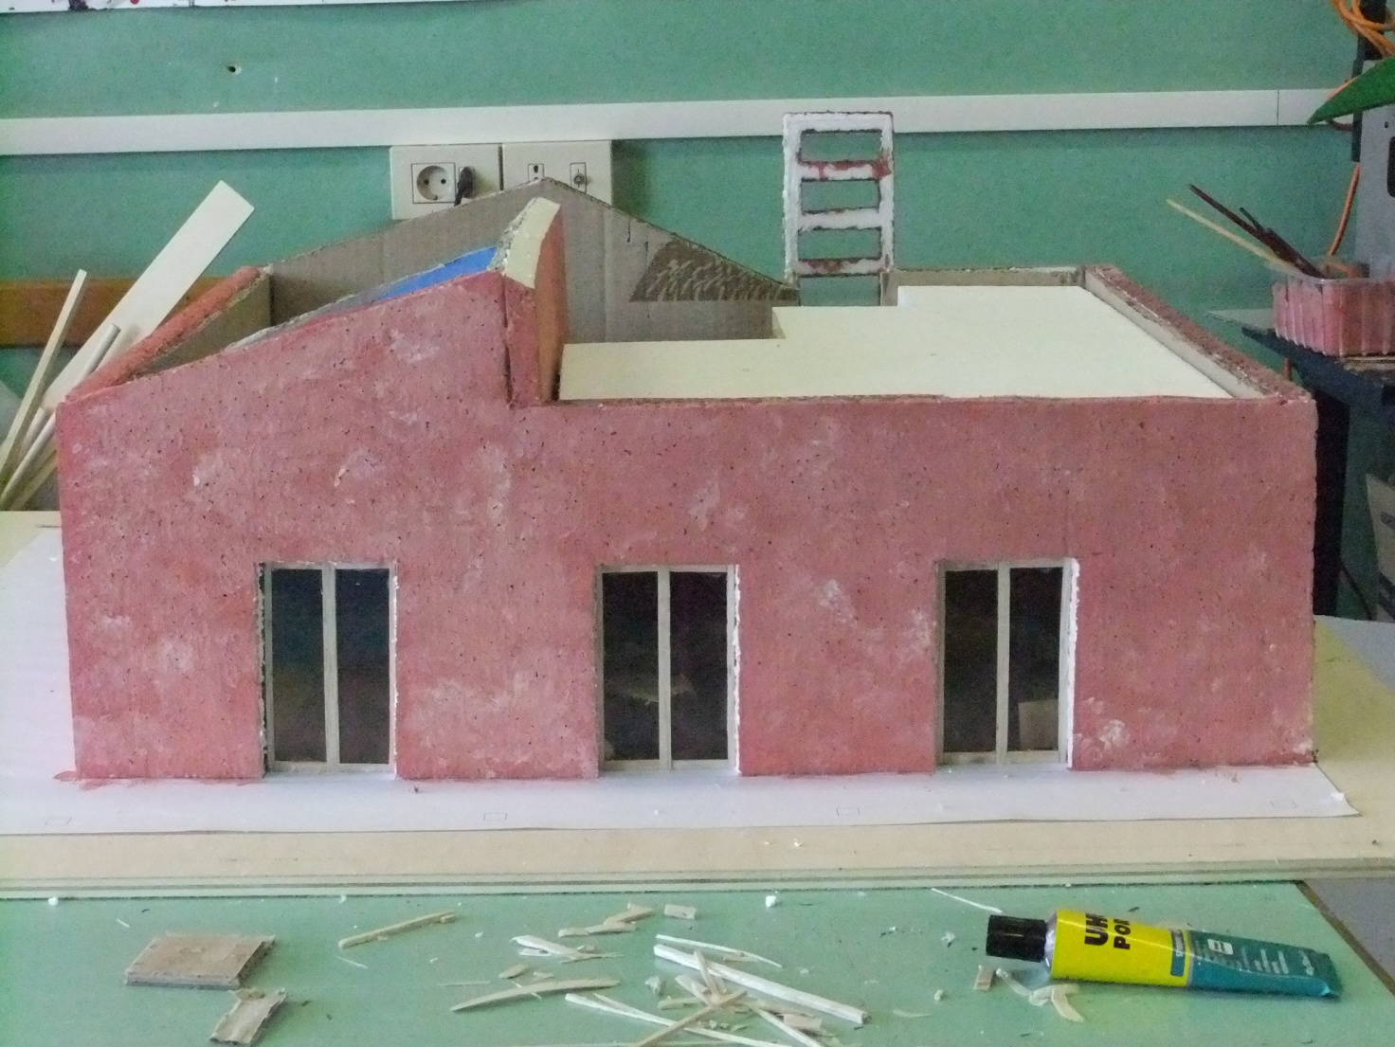
This is the east side of the house with three windows that open in a portico.

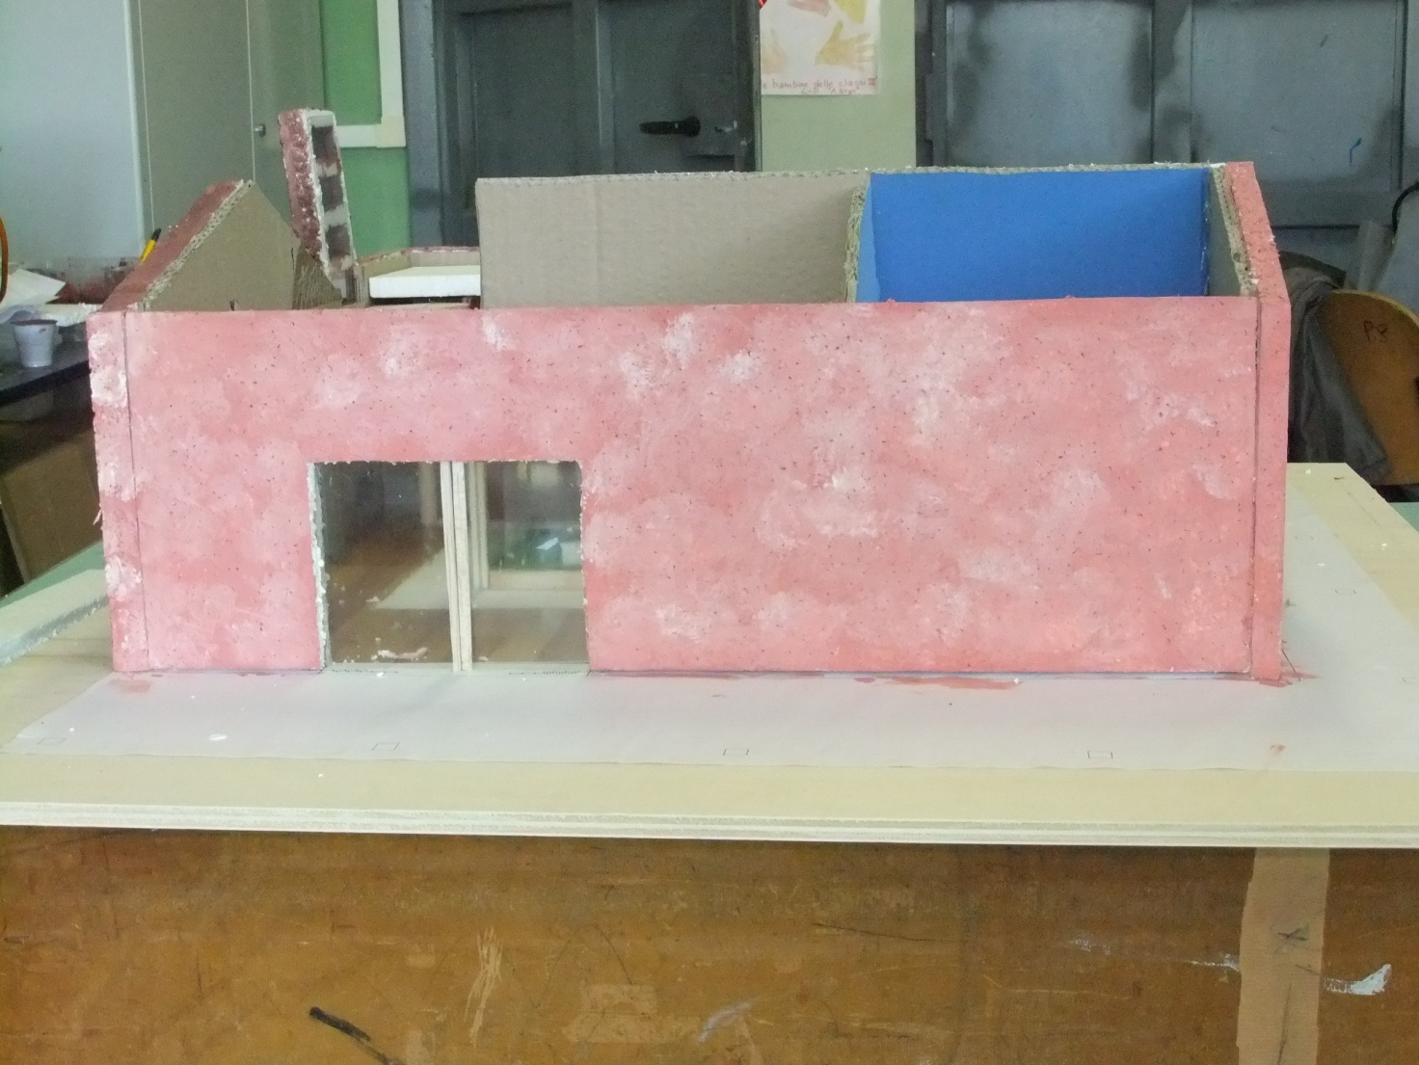
This is the south side with one large window that opens in a portico too.
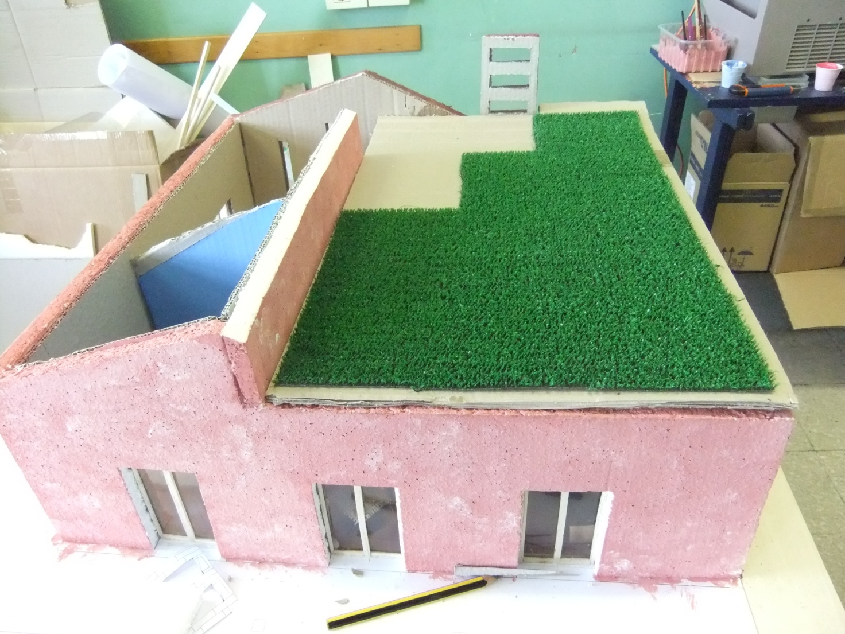
There’s a green area on a part of the roof that is insulating from the hot rays of the sun.

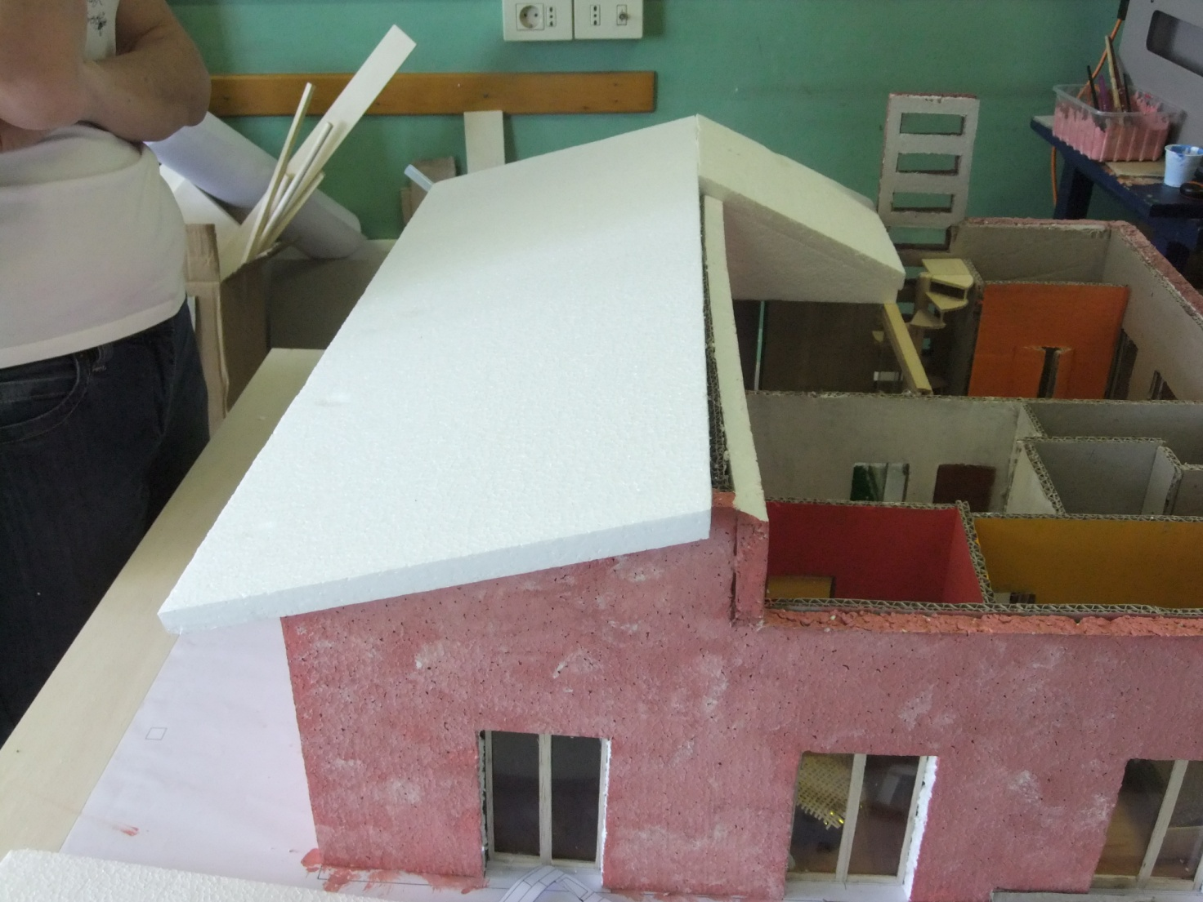
This is the other part of the roof that will be covered with roof tiles.

I’ll send photos of the ended house during next week.

