Polish green house - description and photos for the catalogue

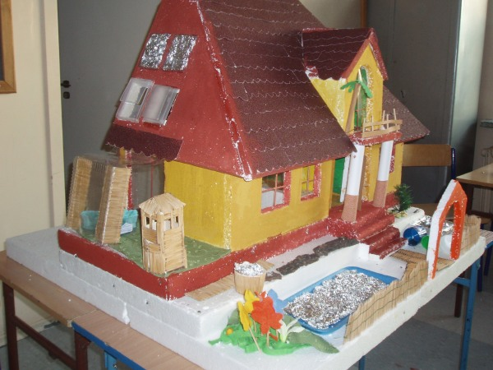

The house is a detatched house which is energy self sufficient and ecologically friendly. It also reflects traditional architecture of Polish houses. It has got a habitable attic where the bedrooms are situated, a terrace, a small winter garden, an entrance through the porch supported by two columns, and a balcony above it.
Materials
- Ceramic bricks
- 15 cm polystyrene insulation of walls
- Roof made of bitumen tiles with mineral wool insulation
- Double glazed windows with external blinds
- Solar panels on the roof
- Wind turbine on a mast near the house
The outside of the house
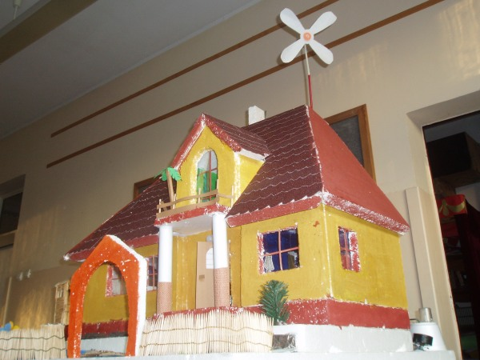
The front of the house with a fence, a gate and a porch.
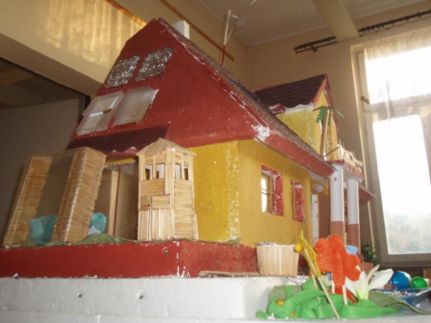 The western wall with a terrace, winter garden and solar panels on the roof.
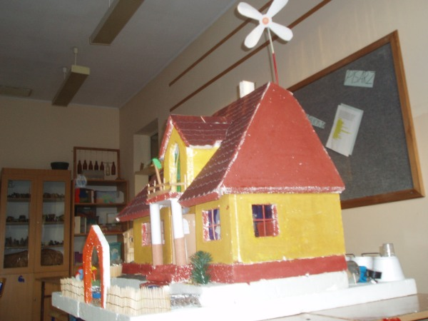
The eastern wall.
Interior design
In the house all furniture is made of natural materials, there are wooden floors and stairs. The house is decorated with handmade tapestries, and woven woolen kelims. There are also fur seat covers on the sofa a carpet on the floor.
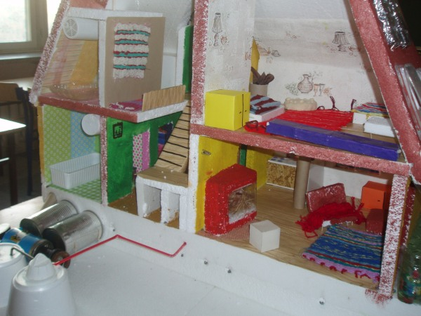
Energy saving
To save energy we use:
- solar panels and a small wind turbine for lighting the house – the metal containers are heat exchangers
- using heat from the earth
- there is a home biogas power plant ( the three white containers behind the bathroom – one produces gas from wc waste water, the other from composte, the third one is for mixing gases) – gas is used for cooking
and for heating the floor
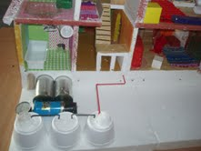

- we use a recuperation system – getting the energy back from chimney wall and the attic mainly in the summer

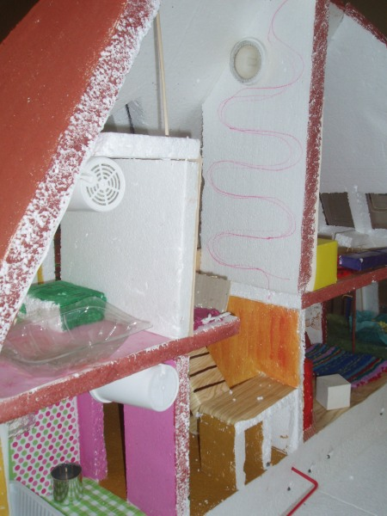

- using Smart Grid technology the surpluses of energy from the house are returned to urban energetic system
- we use energy saving home appliances and light bulbs.

Recycling
- Wastewater from toilets are used for producing gas
- Rain water is collected for watering the garden, one of the containers is traditional Slavonic kneading trough - near the kitchen which than supplies with water the shallow pond in front of the window ( it reflects the sun and gives additional light)
- Plastic, glass and paper is segregated for recycling – three containers near the gate

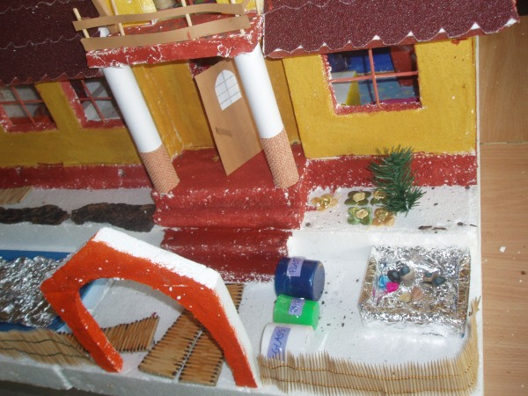

What makes our house green?
- Using renewable sources of energy – solar panels, wind turbine, heat from earth
- Home production of gas for cooking and heating
- Recycling water, paper, glass and plastic
- Using energy-saving appliances
- Using natural materials
- Homemade food- meat smoked in a little wooden tower on the terrace, home-grown vegetables and fruit
Process of constructing
. 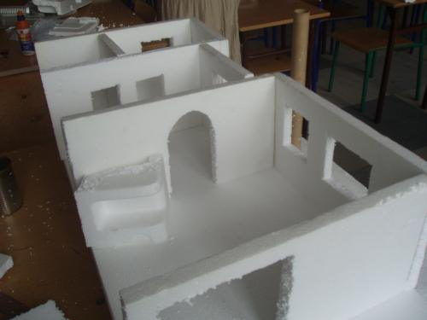

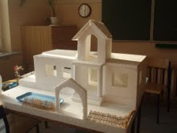
E
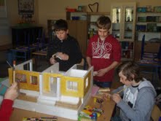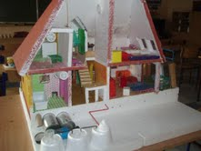
Enngguugujh