The weather in Chios island-Greece
November 14th to 18th 2011

 | 09:00 | 12:00 | 09:00 | 12:00 | 09:00 | 12:00 | 09:00 | 12:00 | 09:00 | 12:00
Date | 14th |  | 15th |  | 16th |  | 17th |  | 18th
Temp sun | 8°C | 11°C | 8°C | 10°C | 8°C | 9°C | 7°C | 8°C | 7°C | 8°C
Temp shadow | 7°C | 9°C | 7°C | 11°C | 7°C | 8°C | 6°C | 7°C | 6°C | 7°C
Rain/snow | 0-mm | 0-mm | 0-mm | 0-mm | 0-mm | 0-mm | 0-mm | 0-mm | 0-mm | 0-mm
Wind m/sec | 7.5m/4s | 5m/4s | 3m/3s | 2m/3s | 8m/5s | 8m/5s | 3m/3s | 3m/4s | 2m/3s | 2m/3s
Weather

The symbols:
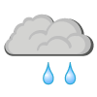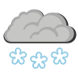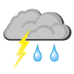

Sun/clear sky Partly cloudy Cloudy Rain Snow Rain and thunder Fog

