The weather in Rome – Italy
November 14th to 18th 2011

 | 09:00 | 12:00 | 09:00 | 12:00 | 09:00 | 12:00 | 09:00 | 12:00 | 09:00 | 12:00
Date | 14th |  | 15th |  | 16th |  | 17th |  | 18th
Temp sun | 8°C | 14°C | 8°C | 15°C | 9°C | 14°C | 9°C | 16°C | 8°C | 16°C
Temp shadow | 7°C | 12°C | 7°C | 13°C | 7°C | 12°C | 8°C | 14°C | 7°C | 14°C
Rain/snow | 0 mm | 0 mm | 0 mm | 0 mm | 0 mm | 0 mm | 0 mm | 0 mm | 0 mm | 0 mm
Wind m/sec | 0,1 m/s | 0,2 m/s | 0,2 m/s | 0,3 m/s | 0,3m/s | 0,3m/s | 0m/s | 0,1 m/s | 0 m/s | 0,2m/s
Weather | 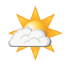

The symbols:
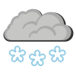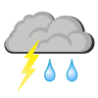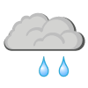

Sun/clear sky Partly cloudy Cloudy Rain Snow Rain and thunder Fog

