Italy was the first country in the world to experiment with and develop electricity production using geothermal fluids. Today the region of Larderello, in Tuscany, is considered the birthplace of geothermal power. The production of electricity from geothermal fluids was first experimented with in 1904 at Larderello by Prince Piero Ginori Conti, who lit five light bulbs using a piston engine coupled to a dynamo powered by natural steam.
In 1913 the first commercial geothermal power plant was installed at Larderello, consisting of 250 kW turbine built and manufactured in Italy by Tosi and marking the beginning of this new industry.
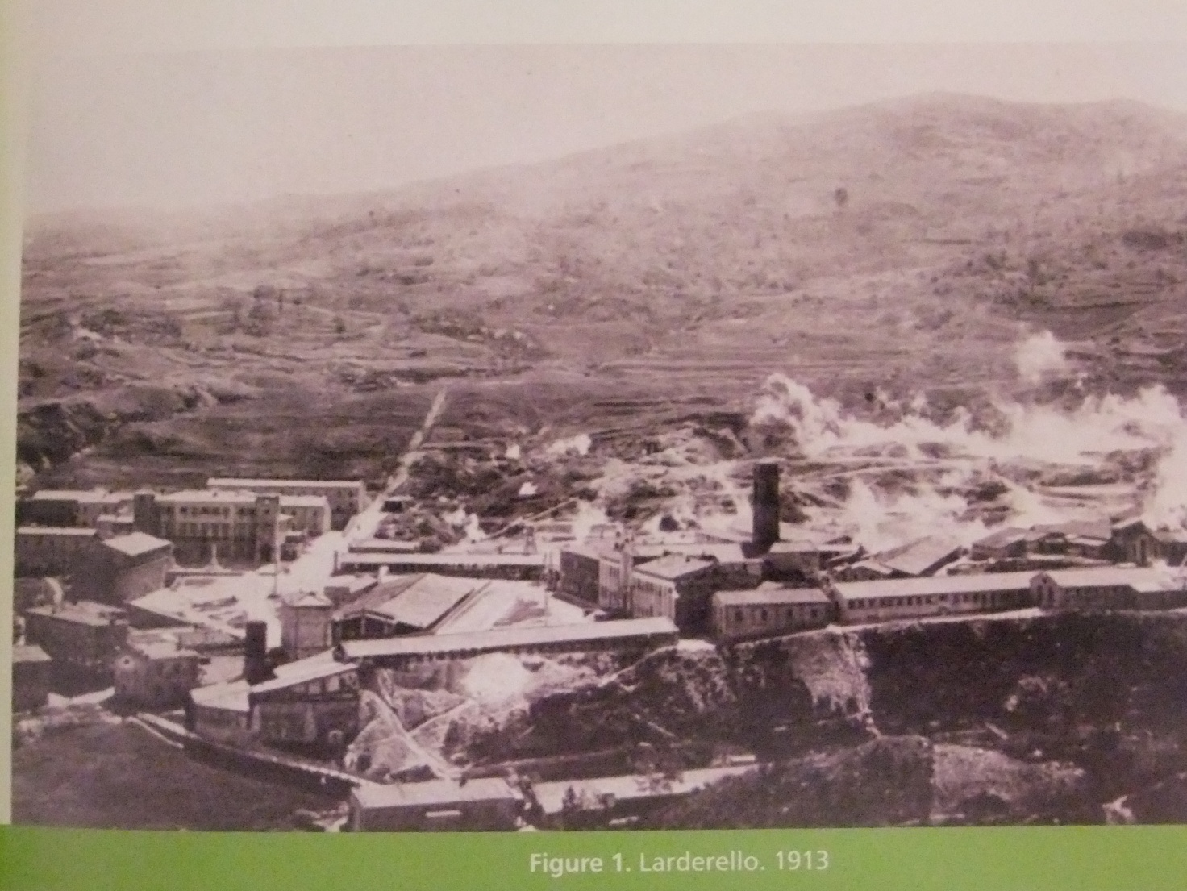
Geothermal energy, the heat which is contained beneath the Earth surface, is steadily moving outward from the hot core of the earth toward the cold of outer space trough the natural processes of conduction and convection.
The origin of this natural energy is attributed to two main sources : the planet’s primordial heat and the heat generated by the decay of earth. radioactive isotopes of elements like uranium,

thorium and potassium that are present in the earth. 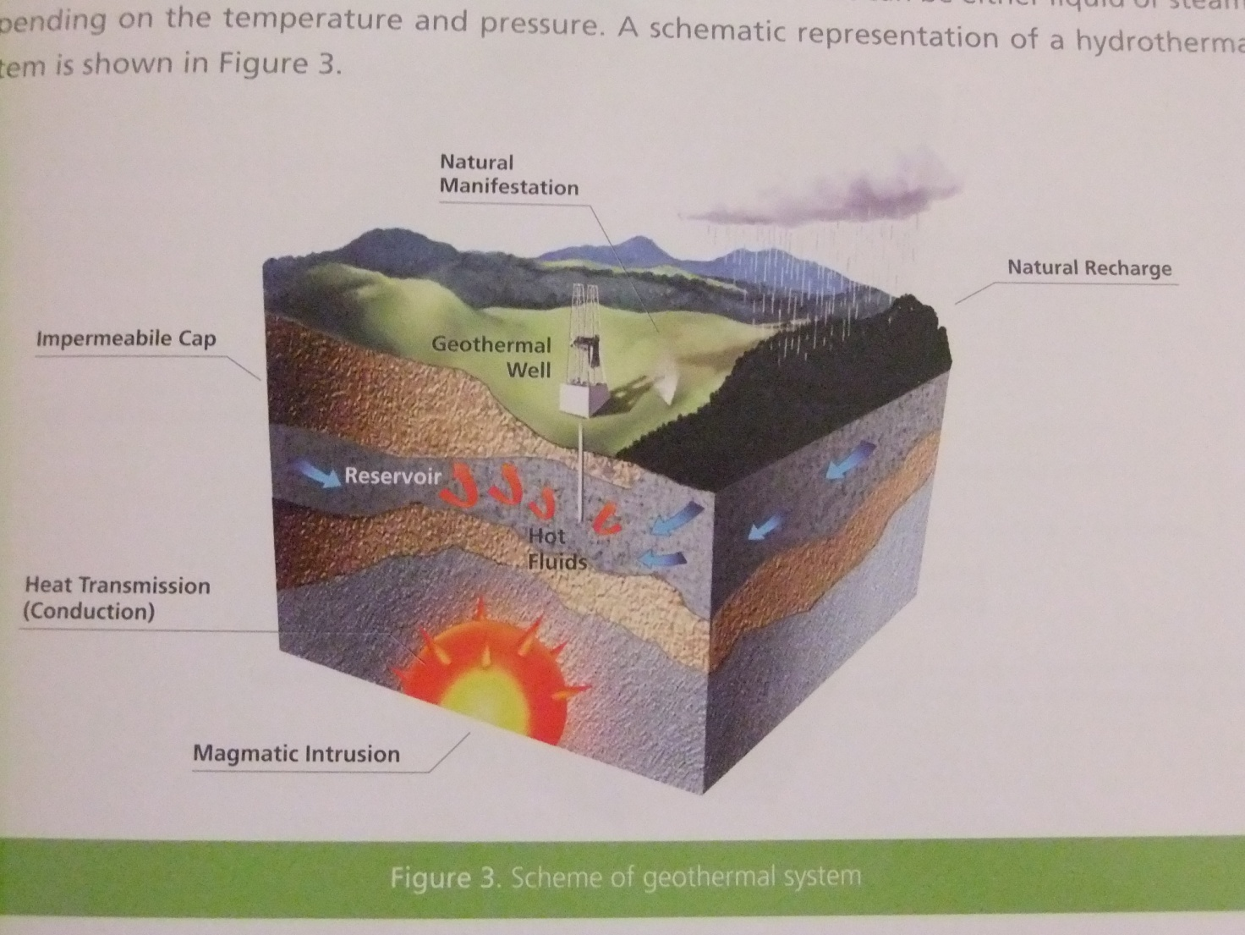
Heat extraction from rocks is achieved by means of water circulation. Depending on the characteristics of the geothermal system, this can be achieved either by natural or forced circulation (i. e. with production and injection pumps). The deep circulating water acquires heat from the contact with high temperature rocks and is then discharged by production wells as steam or biphase fluid.
The geothermal process is thus based on a combined strategy of production and reinjection designed to extract the heat from the underground rock.
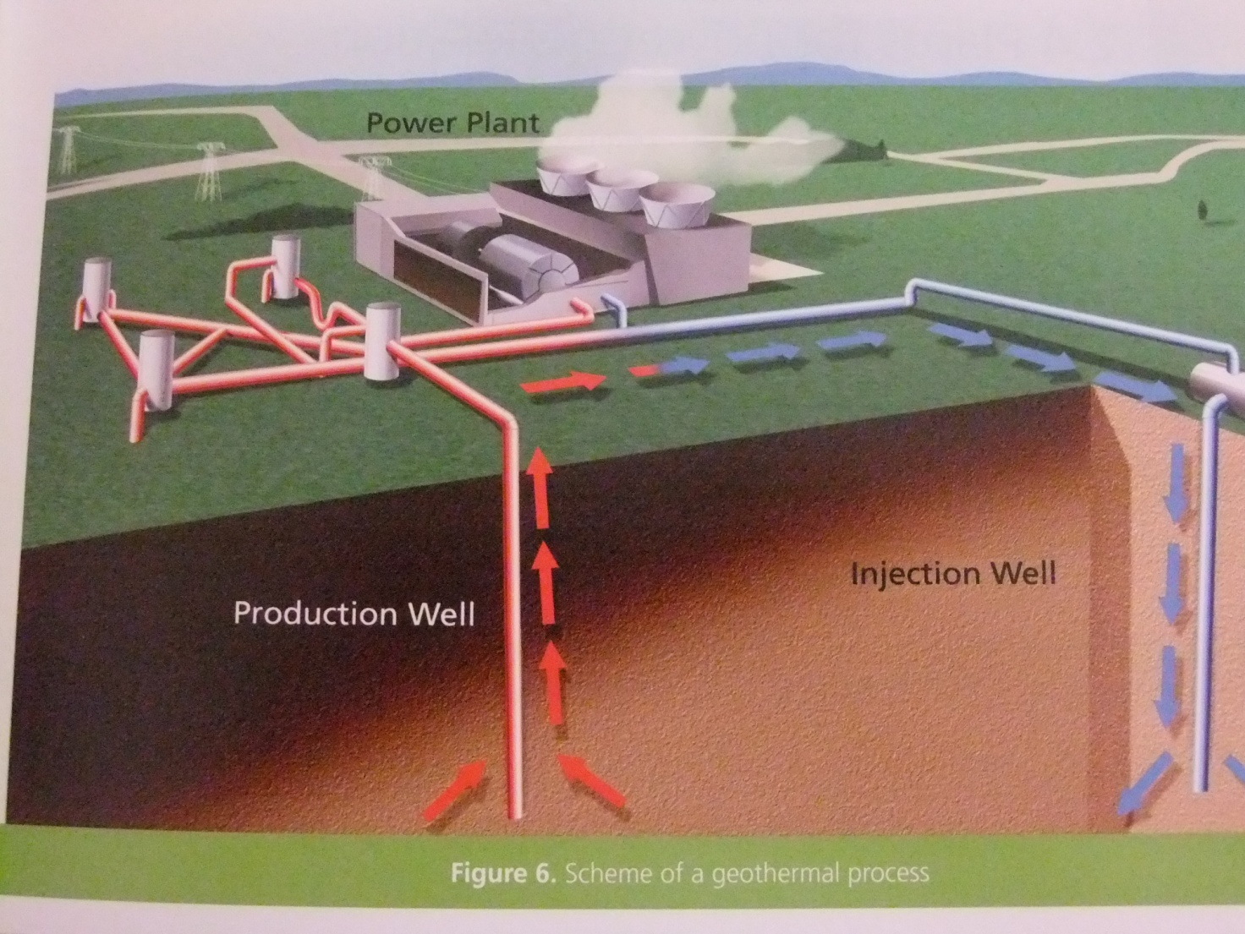
Based on the Italian experience, several other countries around the world have developed the use of geothermal resources for power generation beginning in the late 1950’s.
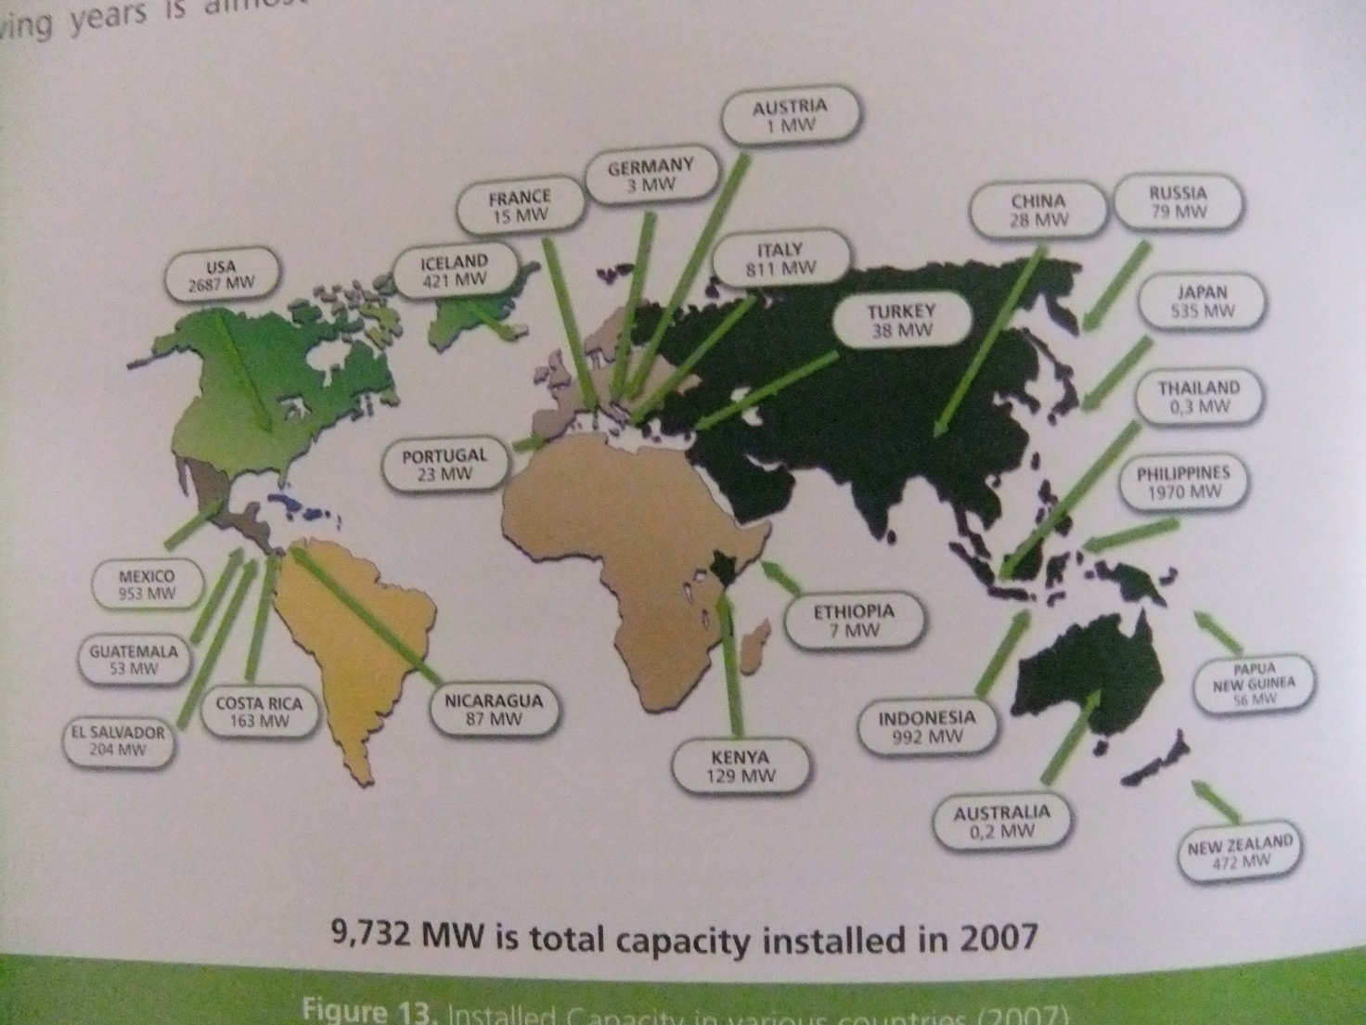
Over 90% of the installed geothermal capacity in the world is concentrated in only a few countries and in some of them the production from geothermal energy accounts for more than 15% of their total electricity generation, as in Iceland, El Salvador, Philippines, Costa Rica, Kenya.
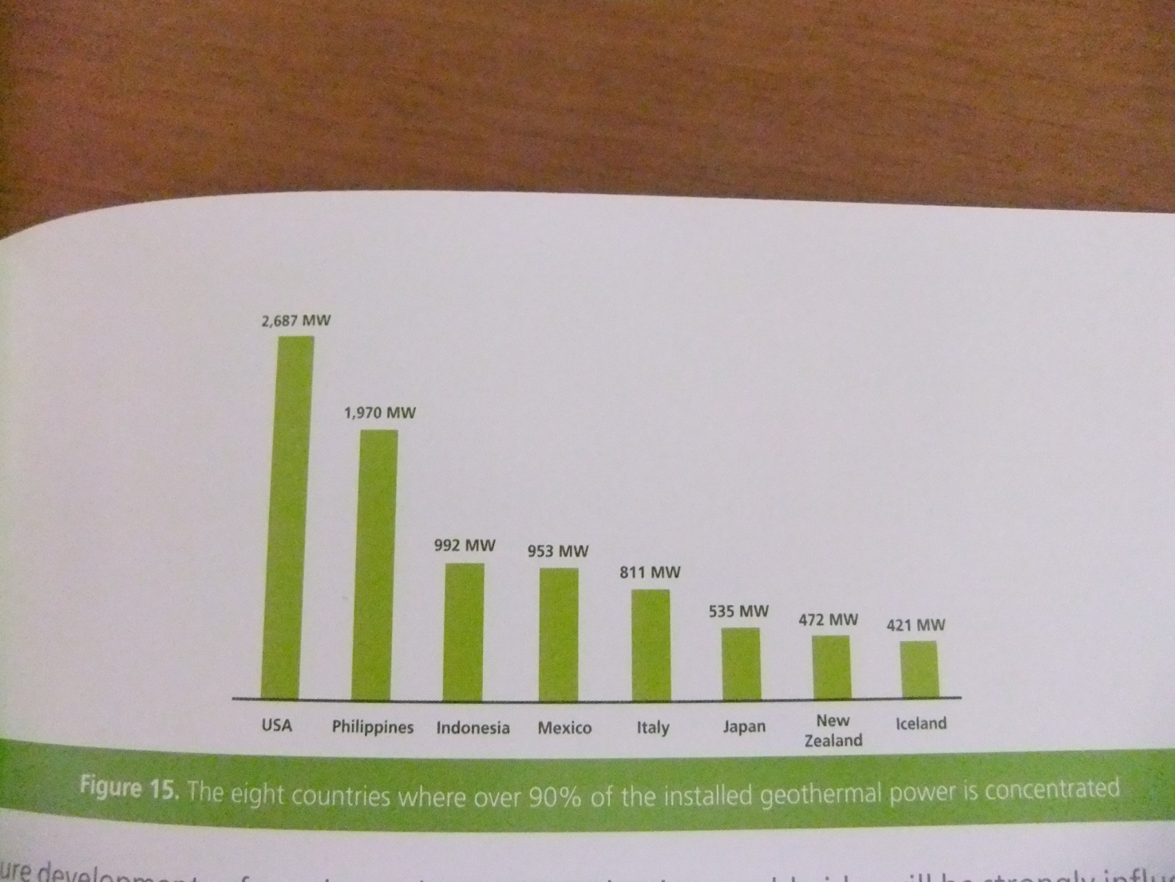
Significant investments have been made in recent years in Italy to improve the environmental impact and the acceptability of geothermal plants.
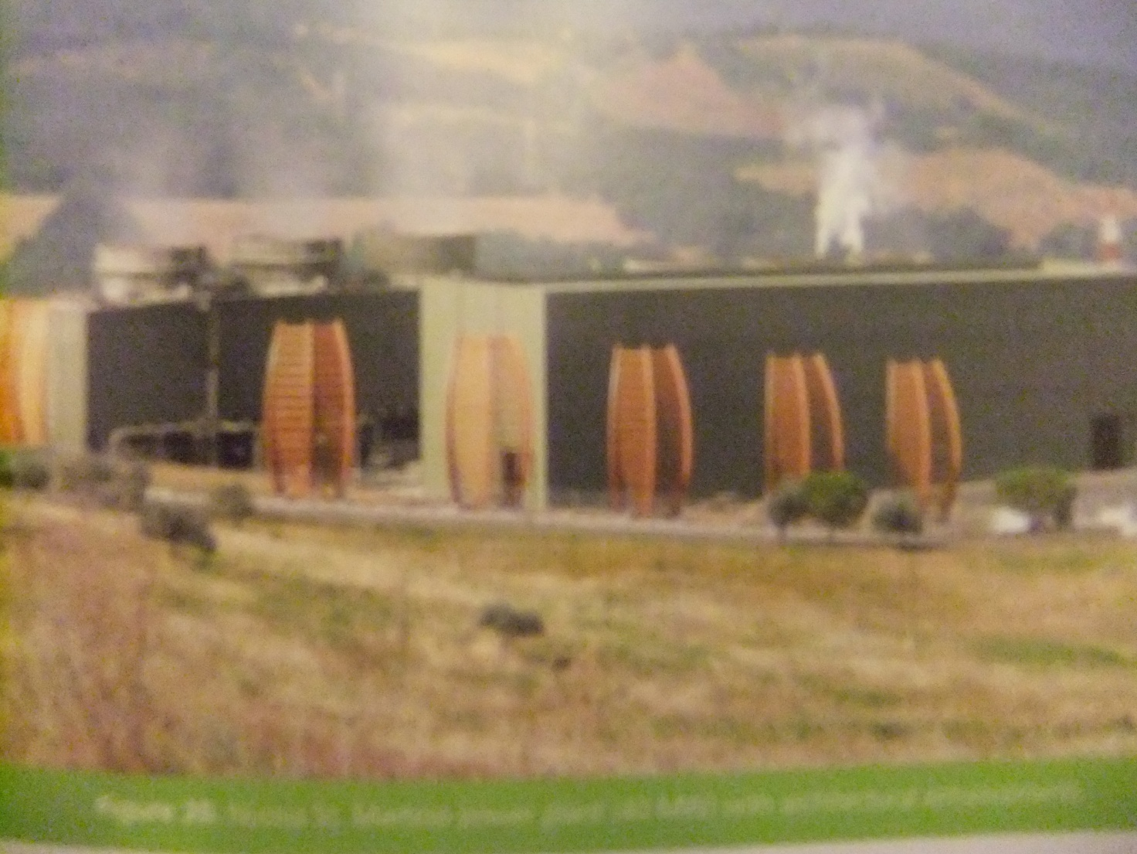
All the Italian geothermal fields are actually located in Tuscany.
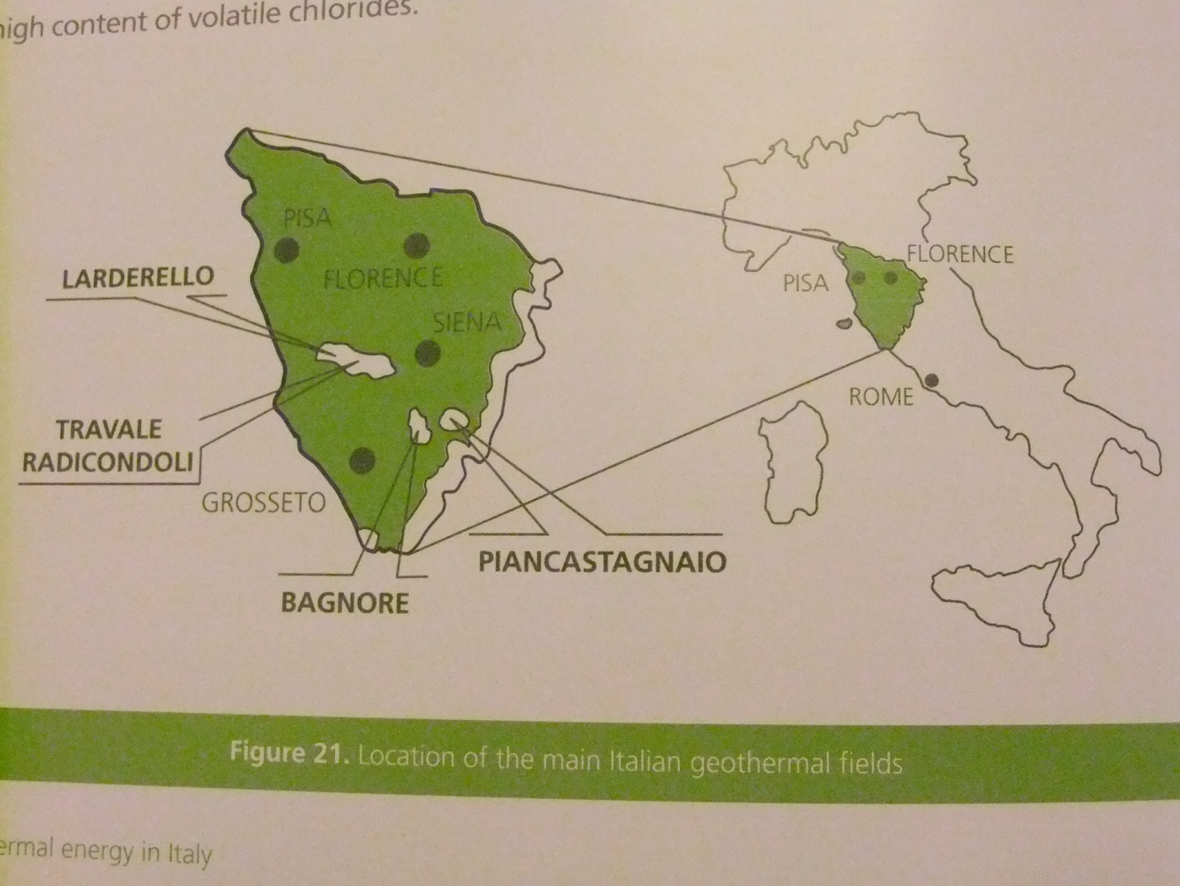
This is the power station and its cooling system.
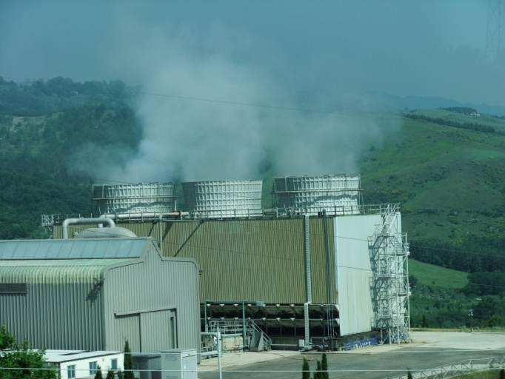

Here we are while we are visiting the geothermal power station in Piancastagnaio in Tuscany.
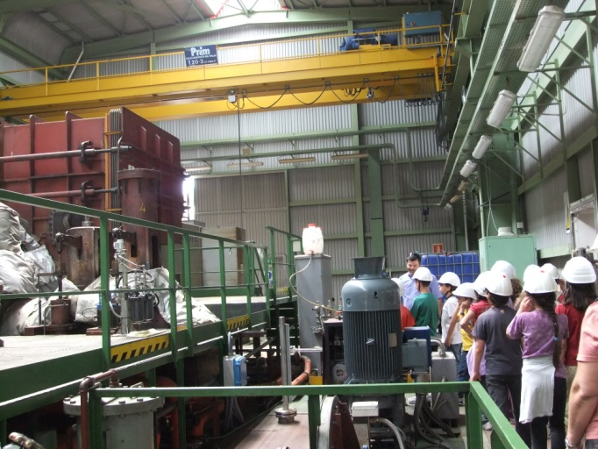

An expert is explaining to us how it works and the importance of this kind of energy source.
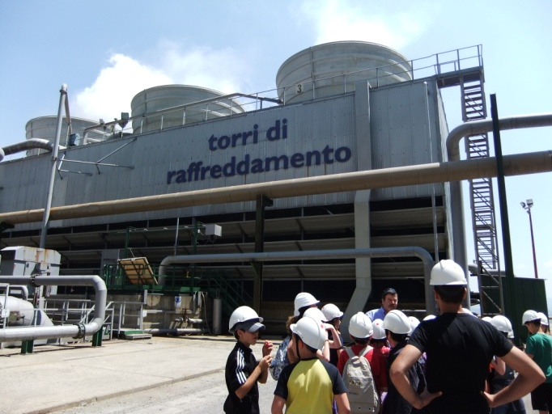

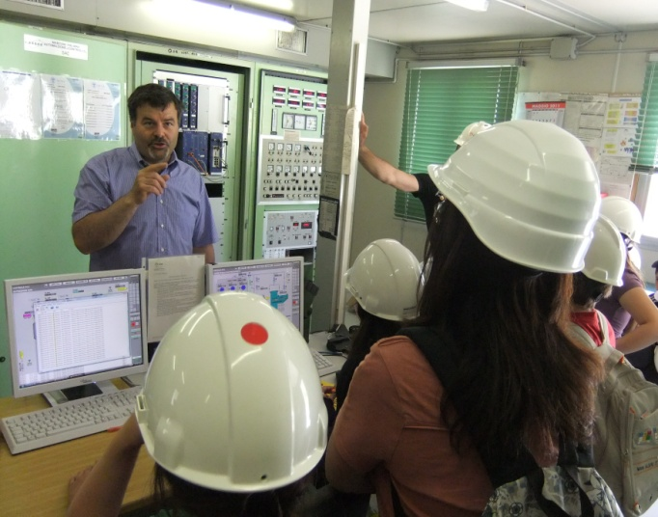
This is the operation centre of the power station from where you can check all the different phases of its work.

