On the 8th of April several pupils from our school visited Żerań Power Plant in Warsaw. During the trip the pupils found out the most common technology for producing electricity. Currently, Vatenfal, Swedish company, uses wind, water, biomass, nuclear energy, coal and gas, depending on the conditions that prevail in different countries where the power plants are built.
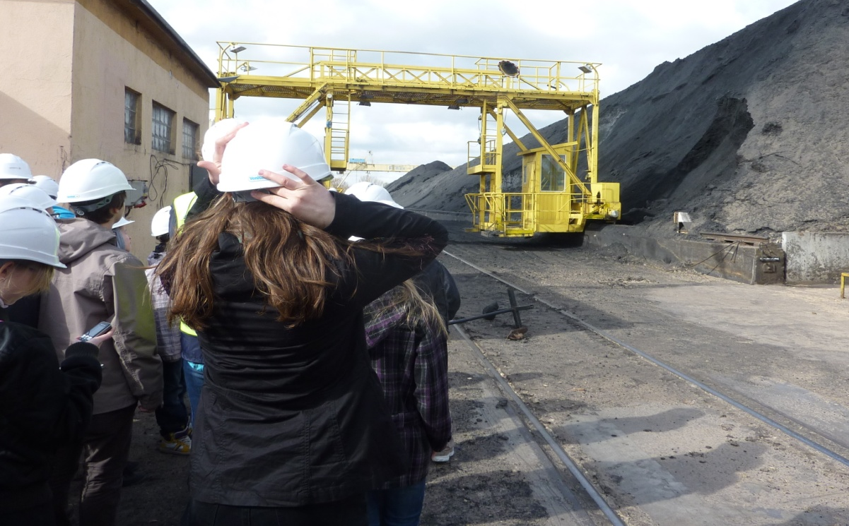

Coal -węgiel

Wood - drewno

There aren’t many employees in the power plant because almost everything is run by computers.
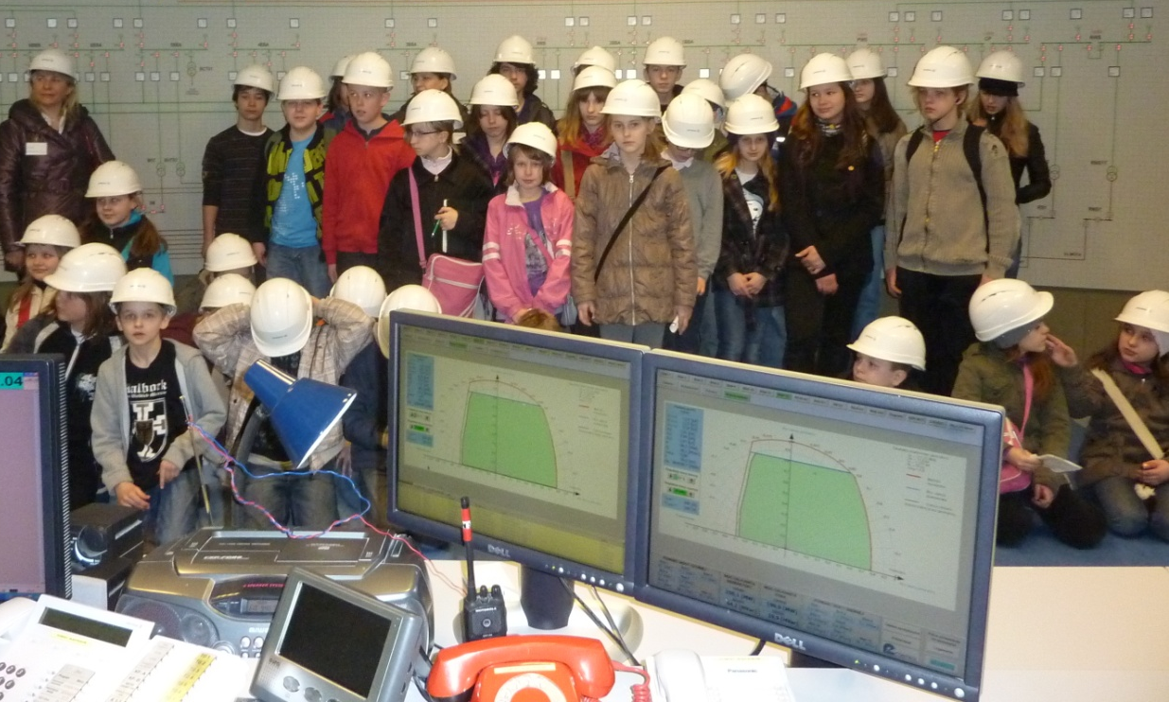
Power plant
elektrownia
On April 4th students from grades 6, under the supervision of teachers went to Świerk near Warsaw, where the Atomic Energy Research Center is located. There they familiarized themselves with the fundamental problems of atomic physics and radioactivity.

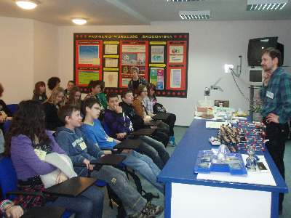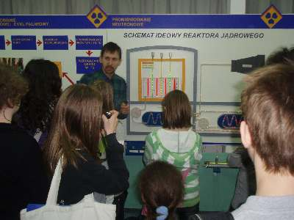
Nuclear reactor- reaktor jadrowy

